./

GENESIS - Learning Outcome & Mini-project Summary Report



|  |  |  |  |  |  |
| --- | --- | --- | --- | --- | --- |
| **Ver. Rel. No.** | **Release Date** | **Prepared. By** | **Reviewed By** | **To be Approved** | **Remarks/Revision Details** |
| 1.1 | 9/11/2020 | Smita Senapati |  |  | Requirements |
| 1.2 | 9/11/2020 | Pavan SL |  |  | Design |
| 1.3 | 9/11/2020 | Vinay Kumar V |  |  | Test Plan |
| FINAL | 11/11/2020 | Smita Senapati, Pavan SL , Vinay Kumar V |  |  | FINAL REPORT |
|  |  |  |  |  |  |

**Details**

Contents

Contents 3

Miniproject [Team] 4

Module: Java and Selenium 4

Topic and Subtopics 4

Requirements: 4

Design: 5

Test Plan for Automation Project 8

Test Plan for Java Project: 9

Implementation Summary 9

Video Summary : 9

Git Link: 9

Git Dashboard 10

Summary 10

Individual Contribution & Highlights: 11

Challenges faced and how were they overcome: 12

Future Scope: 12

**Table of figures:**

Figure 1 Automation Project Structural Diagram 5

Figure 2 Automation Project Behavioral diagram 6

Figure 3 Java Project Behavioral Diagram 7

Figure 4:GIT dashboard 10

Figure 5:Maven Build 11

Figure 6:Code Quality 11

**List of Tables:**

Table 1:High level Requirements 4

Table 2:Low level Requirements 4

Table 3:Test Plan 8

# Miniproject [Team]

## Module: Java and Selenium

### Topic and Subtopics

JAVA Implementation- EMAIL Application

Selenium Automation- SBI Loan Application

Objectives & Requirements:

Objective is to implement core java and selenium automation concepts.

## Requirements:

Table 1:High level Requirements

|  |  |
| --- | --- |
| **ID** | **Description** |
| HL_01 | WebDriver- [WebDriver](https://www.selenium.dev/documentation/en/webdriver/) uses browser automation APIs provided by browser vendors to control browser and run tests. |
| HL_02 | IDE- [IDE](https://selenium.dev/selenium-ide) (Integrated Development Environment) is the tool you use to develop your Selenium test cases. |
| HL_03 | Grid- Selenium Grid allows you to run test cases in different machines across different platforms. |
| HL_04 | Email generation |
| HL_05 | Department Choice |
| HL_06 | Should display the details |

Table 2:Low level Requirements

|  |  |
| --- | --- |
| **ID** | **Description** |
| HL_LL_01_01 | Open a SBI home loan website in chrome. |
| HL_LL_02_01 | Automatically able to fill all the details. |
| HL_LL_02_02 | Automatically able to submit the details. |
| HL_LL_04_01 | First name and Last name |
| HL_LL_05_01 | User input |

## Design:

UML:

Structural diagram:

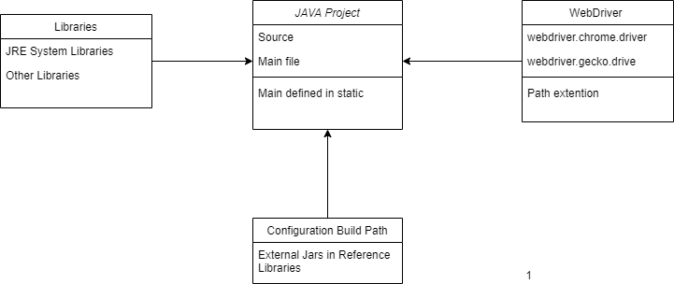

Figure 1 Automation Project Structural Diagram

Behavioral diagram:

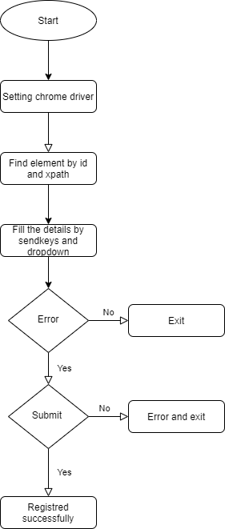

Figure 2 Automation Project Behavioral diagram

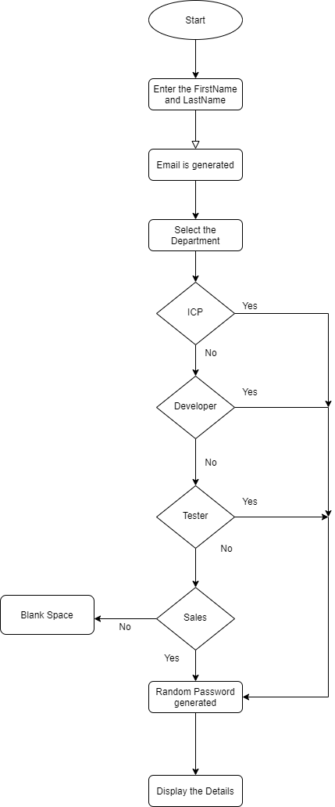

Figure 3 Java Project Behavioral Diagram

## Test Plan for Automation Project

Table 3:Test Plan

| **No.** | **Test Case -ID** | **Test case Objective** | **Prerequisite** | **Steps** | **Input data** | **Expected Result** | **Actual Result** | **Re marks/Status** |
| --- | --- | --- | --- | --- | --- | --- | --- | --- |
| 1 | TC1 | Compulsory fields filling(fields with * symbol) | Website is launched | Don’t fill any of the field with * symbol.  Click submit button | Click submit | Form should not get submitted | Form didn’t submit | Pass |
| 2 | TC-2 | To validate State and their corresponding state areas | Website is launched  Select any State and random Pin code | Select any State and random Pin code | Invalid state with invalid pin | Form validation error | Form validation error | Pass |
| 3. | TC-3 | To validate PAN number | Website is launched | Enter pan number | Aaaaa9090a | Valid pan | Valid pan | Pass |
| 4. | TC4 | To validate mobile number | Website is launched | Enter mobile number according to mobile validation syntax | 9900887766 | Valid number | Valid number | Pass |
| 5 | TC5 | To validate email | Website is launched | Enter email according to email validation syntax | abcd@gmail.com | Valid email | Valid email | Pass |
| 6 | TC6 | To validate terms and conditions | Website is launched | Click terms and conditions checkbox | Click | Submission of form allowed | Submission of form allowed | Pass |

## Test Plan for Java Project:

|  |  |  |  |  |  |  |  |  |
| --- | --- | --- | --- | --- | --- | --- | --- | --- |
| **No.** | **Test Case -ID** | **Test case Objective** | **Prerequisite** | **Steps** | **Input data** | **Expected Result** | **Actual Result** | **Re marks/Status** |
| 1 | TC1 | To validate email | Java application should run | Enter email according to email validation syntax | abcd@gmail.com | Valid email | Valid email | Pass |
| 2 | TC2 | To validate mobile number | Java application should run | Enter mobile number according to mobile validation syntax | 9900887766 | Valid number | Valid number | Pass |
| 3 | TC3 | To validate password | Java application should run | Random function Execution | Password generated by random function | Random password | Random password | Pass |

## Implementation Summary

We have implemented Java and selenium concepts here. Using selenium, we automated a SBI loan page and using java concepts we have developed an EMAIL application. All these things are done using eclipse IDE.

### Video Summary :

A brief walkthrough of automation of SBI home-loan page

### Git Link:

<https://github.com/PS99002489/JAVA_MINI_PROJECT.git>

### Git Dashboard

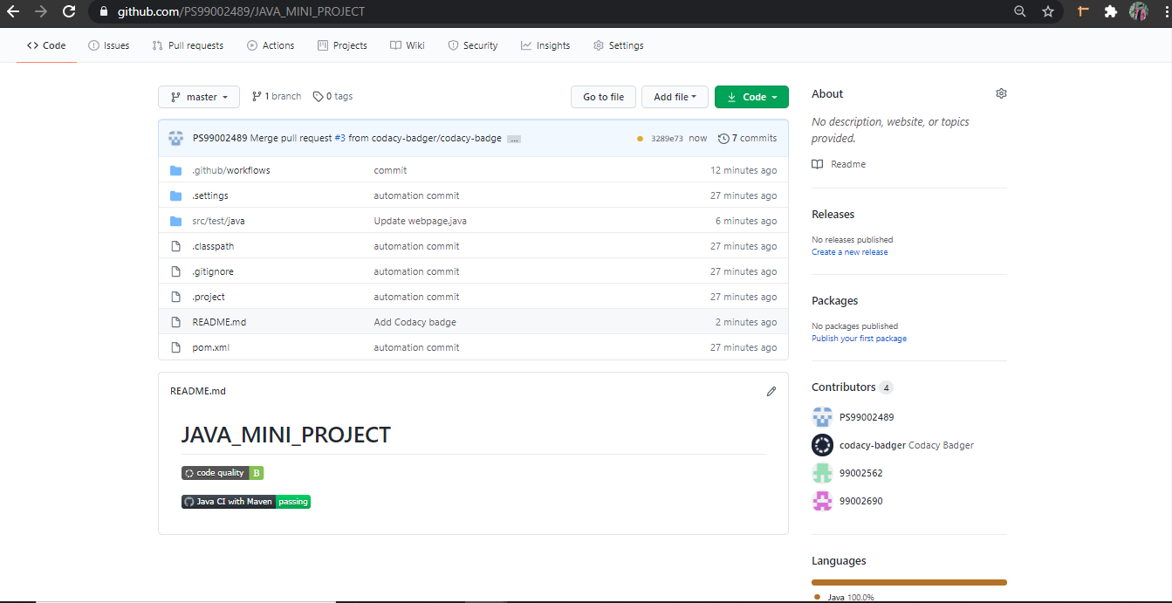

Figure 4:GIT dashboard

### Summary

We have automated a SBI loan webpage by using selenium and by using java we have developed one EMAIL application where email and a random will be created for each new hire.

#### Build

The entire project was built in Maven Project Build Framework.

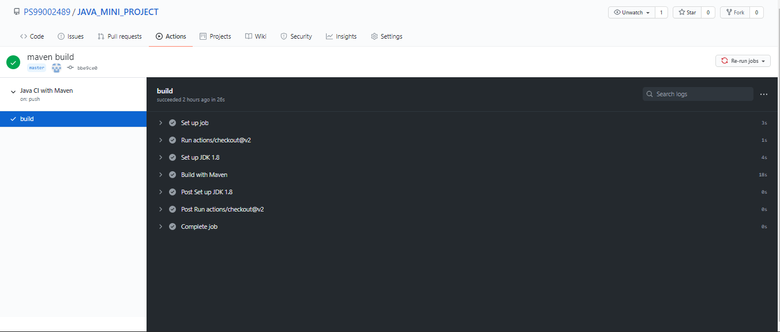

Figure 5:Maven Build

#### Code quality and Issues or Bug Tracking

The Quality of the code is validated in codacy and secured B grade.



Figure 6:Code Quality

### Individual Contribution & Highlights:

* Requirements was documented by Smita.
* Design was documented by Pavan.
* Test plan was documented by Vinay.

### Challenges faced and how were they overcome:

* Difficulty faced while building java project in Git. Overcame this challenge by changing branch to master.
* Difficulty in automating date of birth. Overcame this challenge by giving proper Xpath.

### Future Scope:

Database can be linked for the current project for storing email and password.

### 